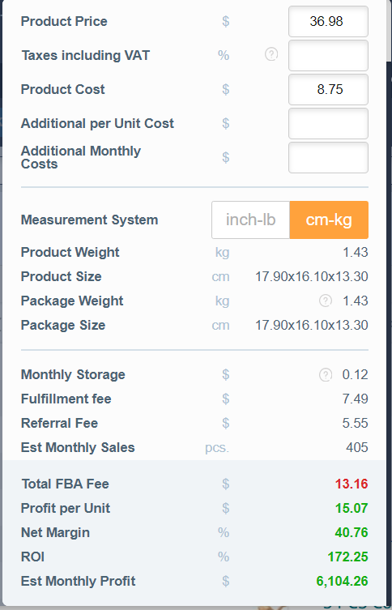

<https://www.amazon.com/dp/B08FR8PCLC>

jsabdfjkasdbfljkasdbfklasdbflkasdjf

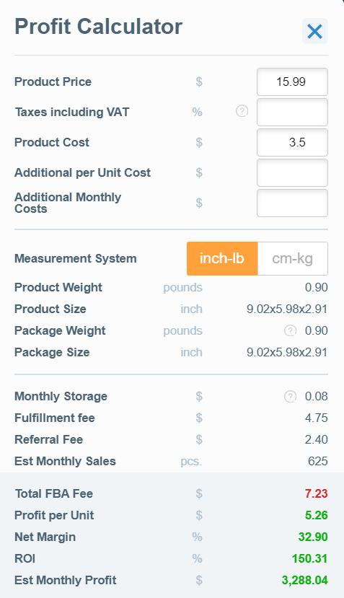

<https://www.amazon.com/dp/B07K8F1J1H>

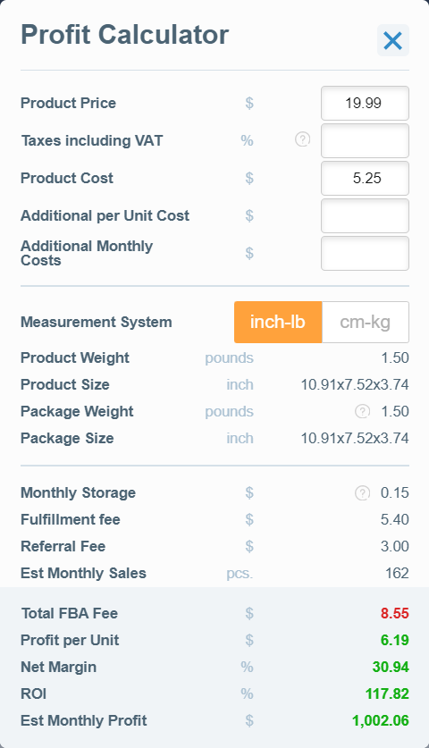

<https://www.amazon.com/dp/B09CYFDRTX>